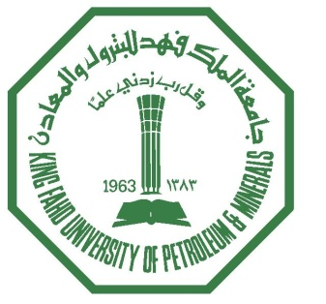

**King Fahd University of Petroleum and Minerals**

**Information and Computer Science Department**

**ICS 324**

**Term 143**

**(Phase 1)**

**Team Number:**

|  |  |
| --- | --- |
| Member | ID |
| Leader: |  |
|  |  |
|  |  |